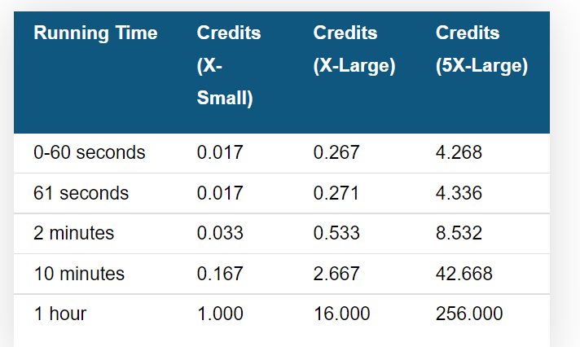

Data loading performance is influenced more by the number of files being loaded (and the size of each file) than the size of the warehouse.

* By default, auto-suspend is enabled. Snowflake automatically suspends the warehouse if it is inactive for the specified period of time.
* By default, auto-resume is enabled. Snowflake automatically resumes the warehouse when any statement that requires a warehouse is submitted ***and*** the warehouse is the current warehouse for the session.

Auto-suspend ensures that you do not leave a warehouse running (and consuming credits) when there are no incoming queries. Similarly, auto-resume ensures that the warehouse starts up again as soon as it is neede

Auto-suspend and auto-resume apply only to the entire warehouse and not to the individual clusters in the warehouse.

Auto-suspend and auto-resume apply only to the entire warehouse and not to the individual clusters in the warehouse.

Snowflake provides some object-leve

l parameters that can be set to help control query processing and concurrency:

* [STATEMENT_QUEUED_TIMEOUT_IN_SECONDS](https://docs.snowflake.com/en/sql-reference/parameters.html#label-statement-queued-timeout-in-seconds)
* [STATEMENT_TIMEOUT_IN_SECONDS](https://docs.snowflake.com/en/sql-reference/parameters.html#label-statement-timeout-in-seconds)

If queries are queuing more than desired, another warehouse can be created and queries can be manually redirected to the new warehouse.

In addition, resizing a warehouse can enable limited scaling for query concurrency and queuing; however, warehouse resizing is primarily intended for improving query performance.

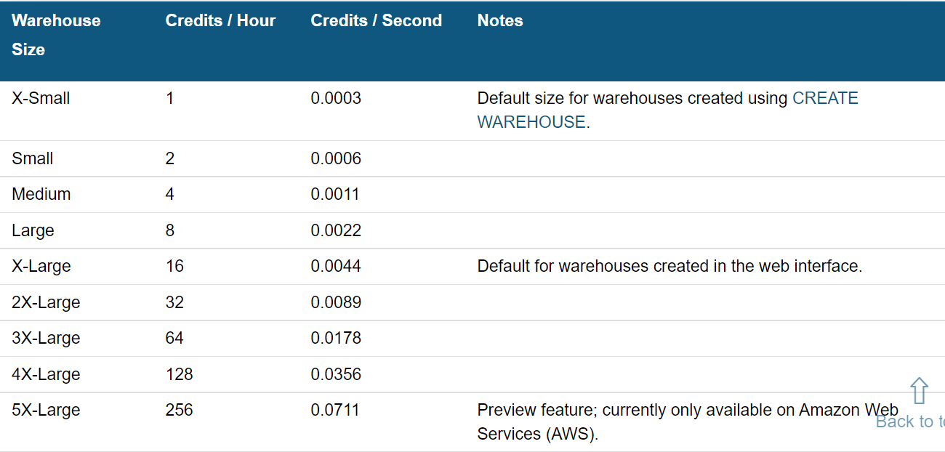

**Classic Web Interface**

Click on **Account**  » **Billing & Usage**

**SQL**

Query any of the following:

* Table functions (in the [Snowflake Information Schema](https://docs.snowflake.com/en/sql-reference/info-schema.html)):
  + [DATABASE_STORAGE_USAGE_HISTORY](https://docs.snowflake.com/en/sql-reference/functions/database_storage_usage_history.html)
  + [STAGE_STORAGE_USAGE_HISTORY](https://docs.snowflake.com/en/sql-reference/functions/stage_storage_usage_history.html)
* Views (in [Account Usage](https://docs.snowflake.com/en/sql-reference/account-usage.html)):
  + [DATABASE_STORAGE_USAGE_HISTORY](https://docs.snowflake.com/en/sql-reference/account-usage/database_storage_usage_history.html)
  + [STAGE_STORAGE_USAGE_HISTORY](https://docs.snowflake.com/en/sql-reference/account-usage/stage_storage_usage_history.html)

**Snowsight**

Select **Data** » [Databases](https://docs.snowflake.com/en/user-guide/ui-snowsight-manage-data.html#label-snowsight-database-details).

On the left side of the **Databases** page, drill down into the database object explorer. Expand a database, then any schema in the database. Click on any table to view the table statistics, including its size.

**Classic Web Interface**

Click **Databases**  » *<db_name>* » **Tables**

**SQL**

Execute a [SHOW TABLES](https://docs.snowflake.com/en/sql-reference/sql/show-tables.html) command.

In addition, users with the ACCOUNTADMIN role can use SQL to view table size information:

**SQL**

Query either of the following:

* [TABLE_STORAGE_METRICS](https://docs.snowflake.com/en/sql-reference/info-schema/table_storage_metrics.html) view (in the [Snowflake Information Schema](https://docs.snowflake.com/en/sql-reference/info-schema.html)).
* [TABLE_STORAGE_METRICS](https://docs.snowflake.com/en/sql-reference/account-usage/table_storage_metrics.html) view (in [Account Usage](https://docs.snowflake.com/en/sql-reference/account-usage.html)).

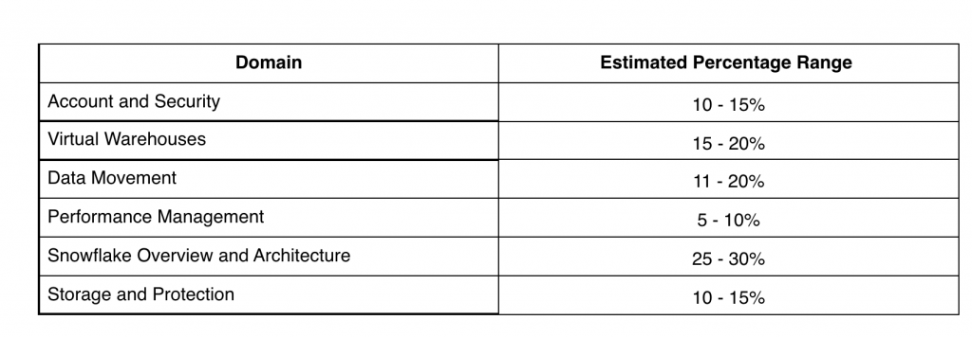

1. Account and Security (10 – 15%)

Candidates will be evaluated on their knowledge of Snowflake accounts and security, including:

* Snowflake accounts and usage monitoring
* Security principles and policies like Multi-factor Authentication (MFA), Single Sign-On (SSO), data encryption, access control, and federated authentication
* Snowflake roles and entities including Role Hierarchy and Privilege Inheritance
* Snowflake Data Governance and security features like data masking and External Tokenization

### 2. Virtual Warehouses (15 – 20%)

Virtual warehouse is an important Snowflake capability that allows data manipulation using SQL. Using Snowflake, candidates must learn how virtual warehouses provision compute, memory, and storage resources. Recommended topics also include:

* Learning about compute principles like credit usage, billing, concurrency, and caching
* Understanding virtual warehouse best practices for monitoring, management, and scaling

### 3. Data Movement (11 – 20%)

Data lies at the heart of Snowflake. Candidates will be evaluated on their abilities to manipulate data, including:

* Differentiation between data loading commands like COPY, INSERT, PUT, GET, and VALIDATE
* Defining bulk vs. continuous data loading methods like COPY and Snowpipe
* Data loading best practices for file size and folders
* Best practices and formats for unloading data from Snowflake to local storage or cloud storage
* Manipulating semi-structured data

### 4. Performance Management (5 – 10%)

Candidates must be aware of the best practices for Snowflake performance management on storage and virtual warehouses. Important topics for this section are:

* Best practices for clustering, materialized views, and search optimization on storage
* Best practices for query performance and analysis, query profiles, query history, SQL optimization, and caching on virtual warehouses

### 5. Snowflake Overview and Architecture (25 – 30%)

To pass the SnowPro Core exam, candidates must focus on mastering the Snowflake architecture, accounting for a significant portion of the exam. It outlines major Snowflake components and capabilities, including:

* Snowflake’s cloud data platform
* Data marketplace and web interface (UI)
* Snowflake’s data sharing functionalities
* Snowflake versus legacy warehouse solutions
* Features of different Snowflake editions
* Snowflake’s Partner Ecosystem including cloud partners and connectors
* Snowflake’s three distinct layers, i.e., storage layer, compute layer, and cloud services layer
* Snowflake’s catalog and objects including database, schema, tables types, view types, data types, and external functions

### 6. Storage and Protection (10 – 15%)

This section revolves around Snowflake’s storage and data protection concepts. Candidates must learn the following topics to ace the related SnowPro Core questions:

* Snowflake’s storage concepts like micro partitions, metadata types, clustering, data storage, stage types, file formats, and storage monitoring
* Continuous data protection including time travel, fail safe, data encryption, and cloning
* Introduction to Snowflake
* Connecting to Snowflake
* Loading/unloading data to Snowflake
* Web interface, virtual warehouses, databases, queries, semi-structured data, and data pipelines
* Data security in Snowflake
* Snowflake accounts
* Developing applications with Snowflake

Test1 (results)

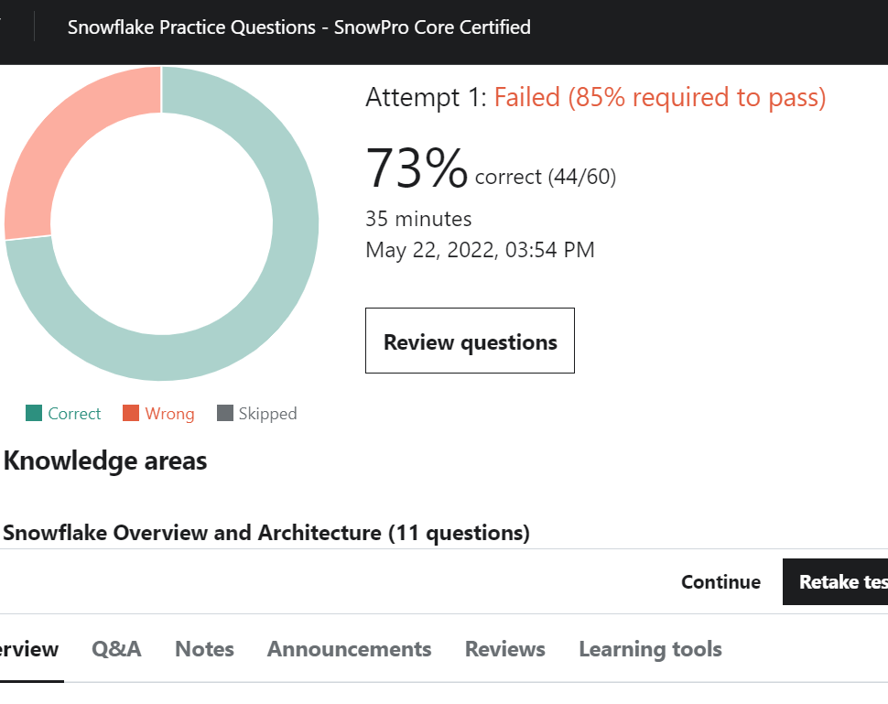

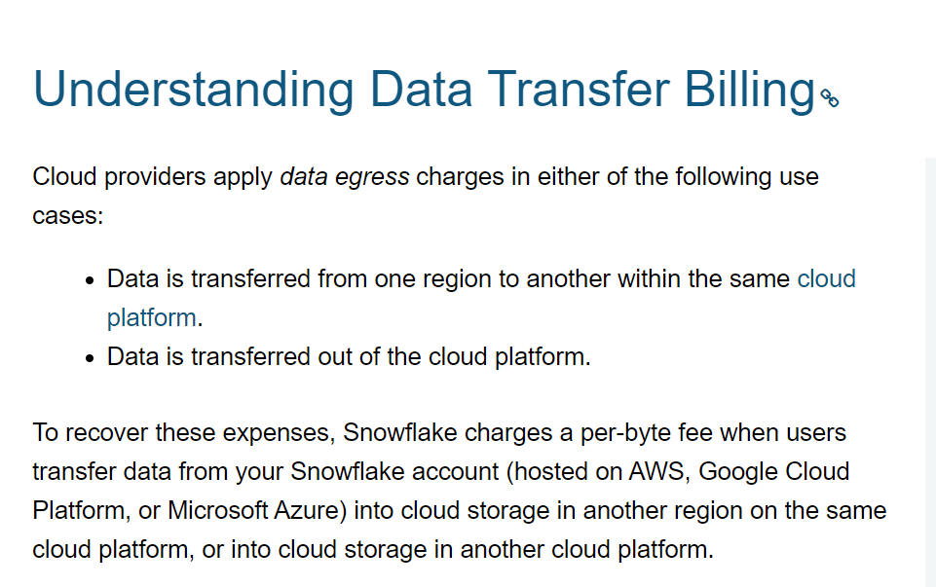

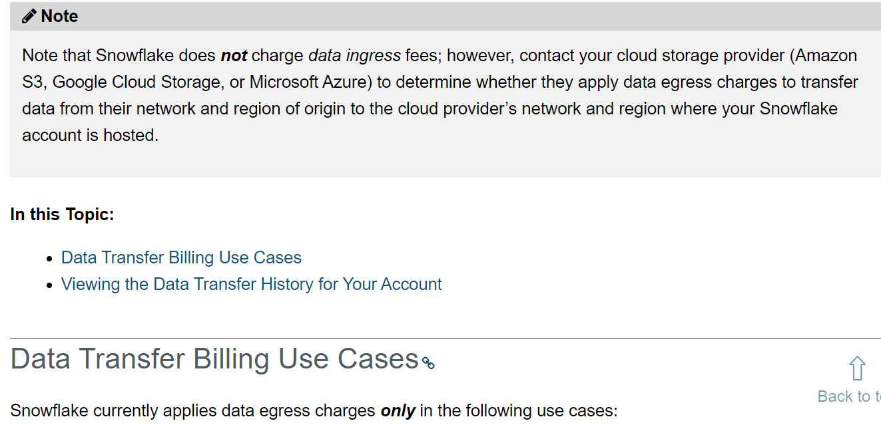

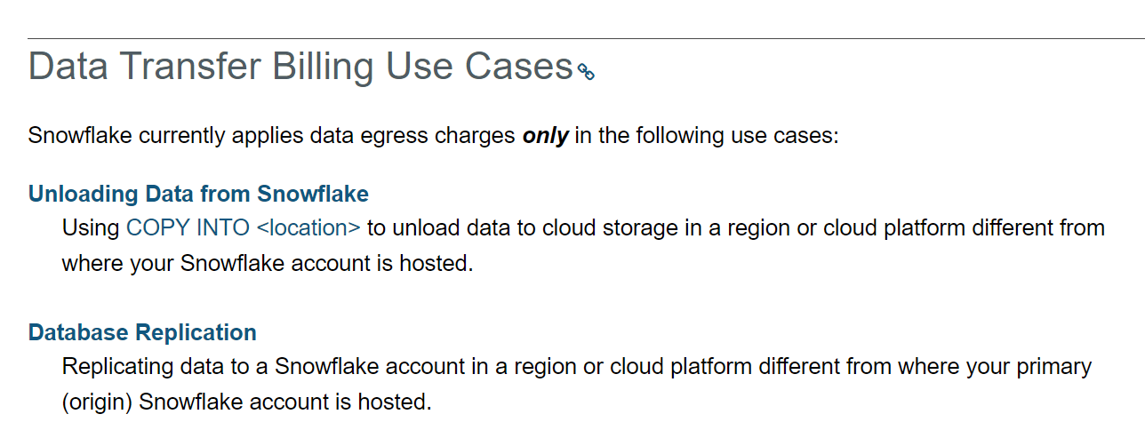

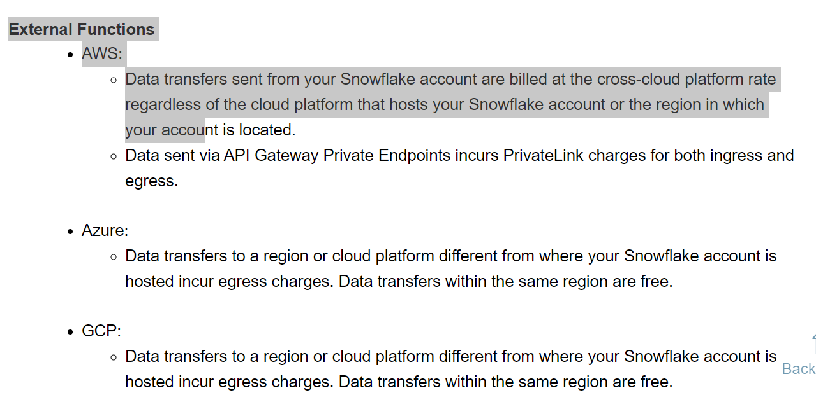

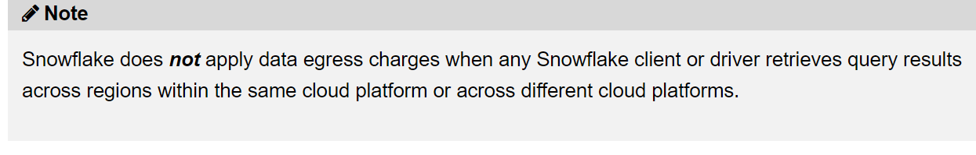

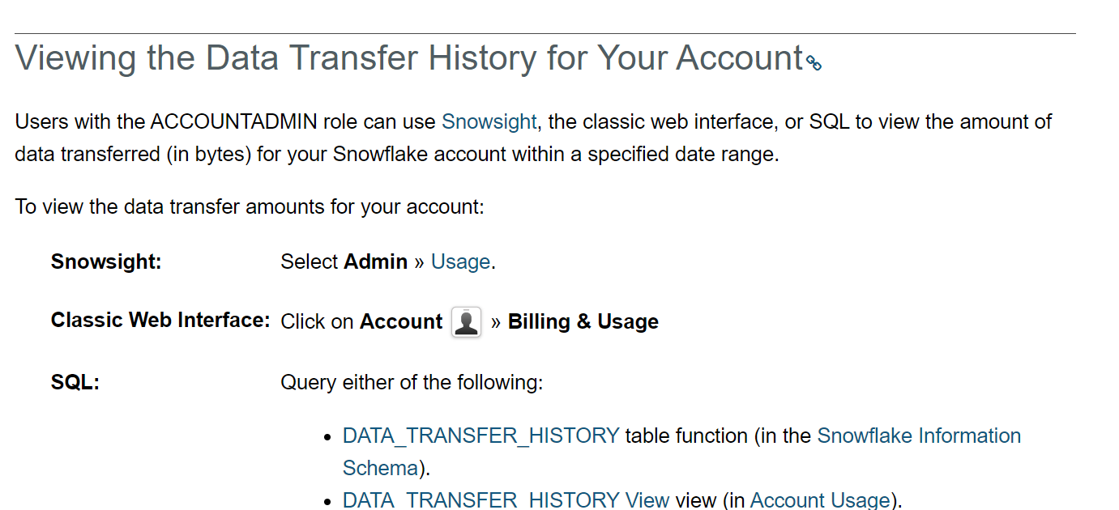



6.6.21 (topic started)

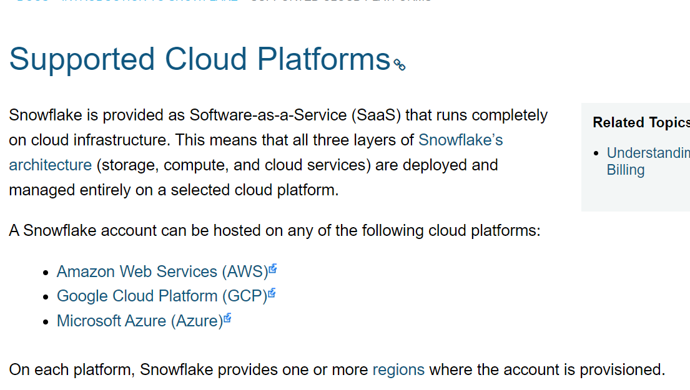

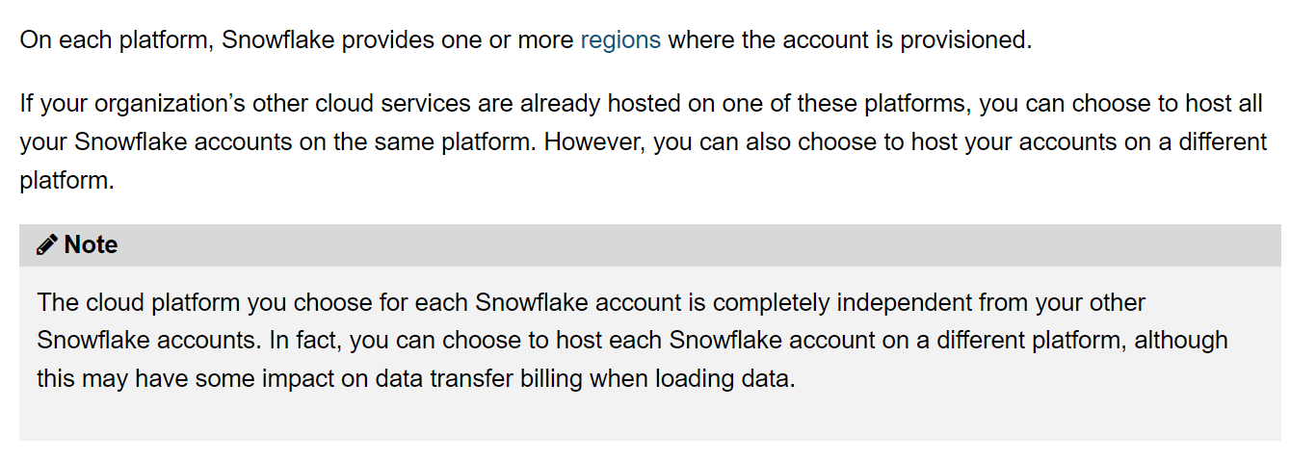

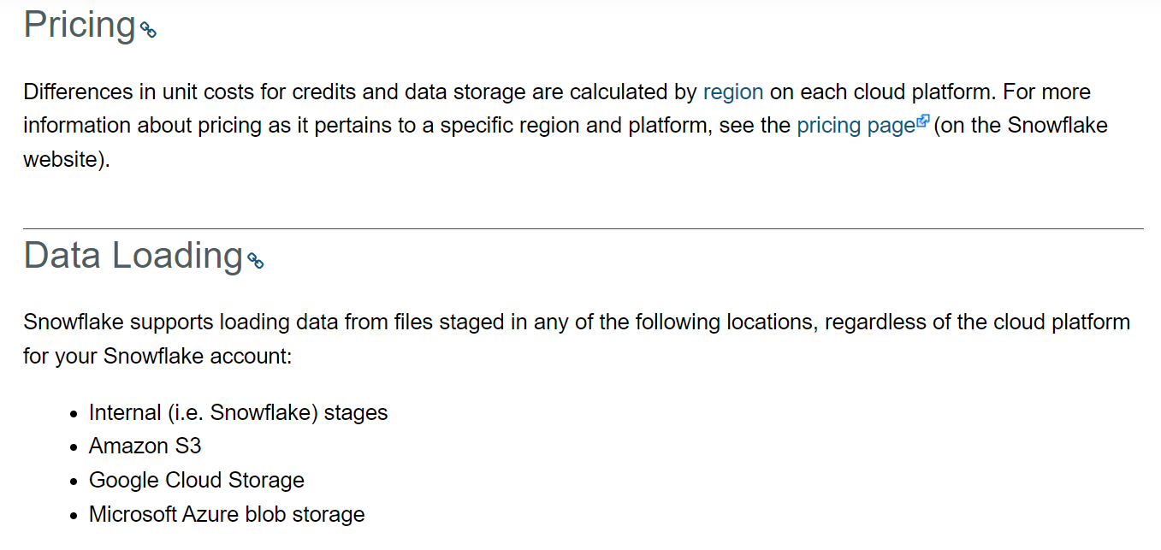

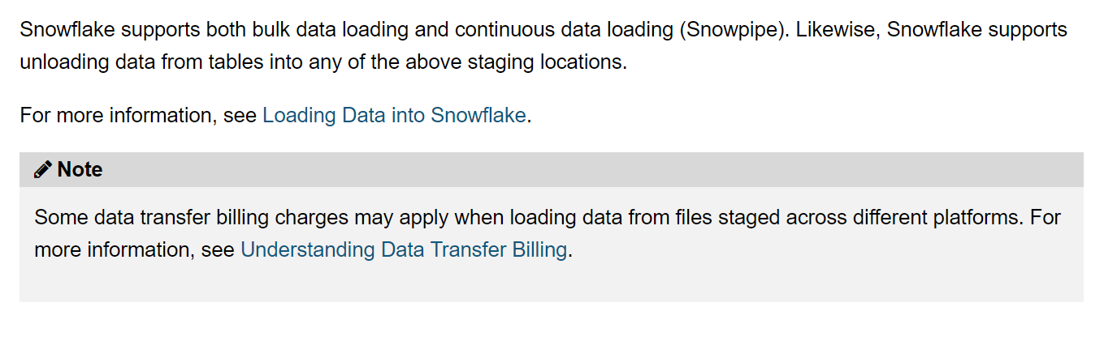

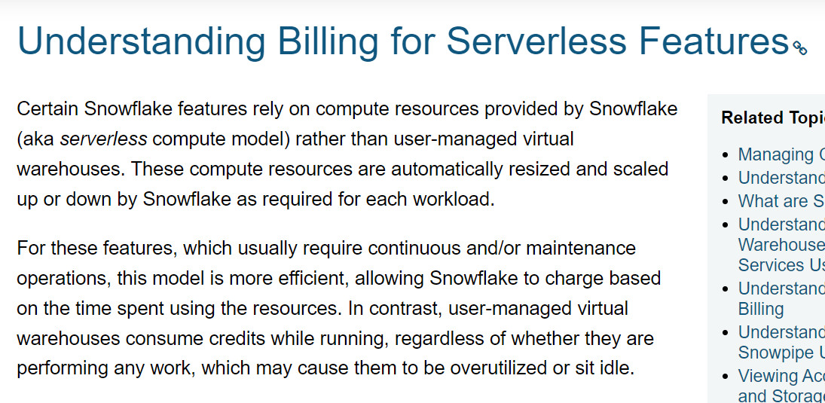

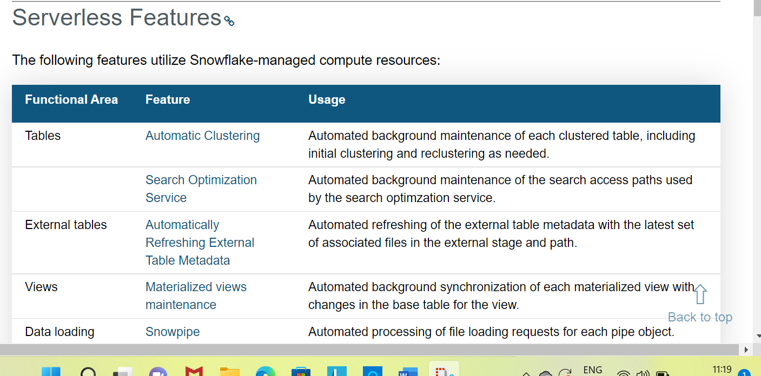

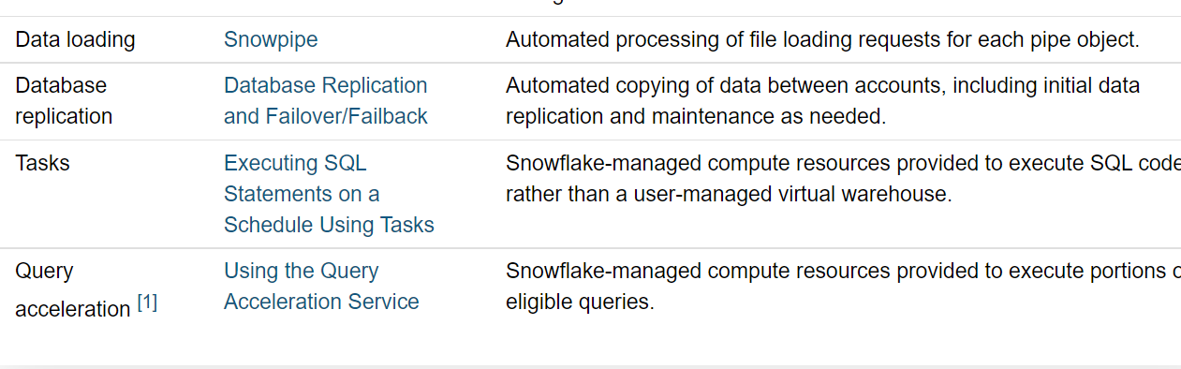

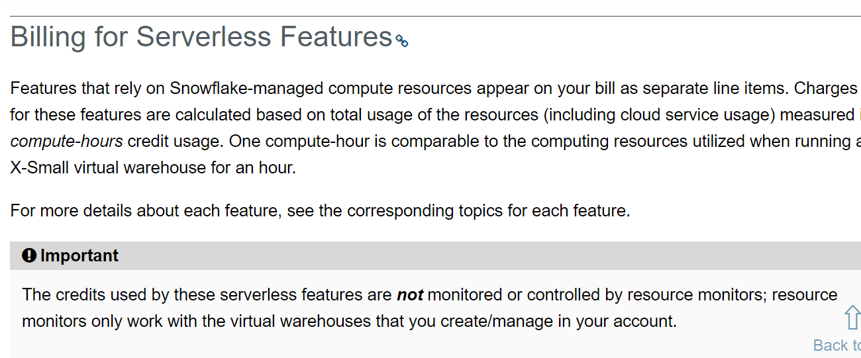

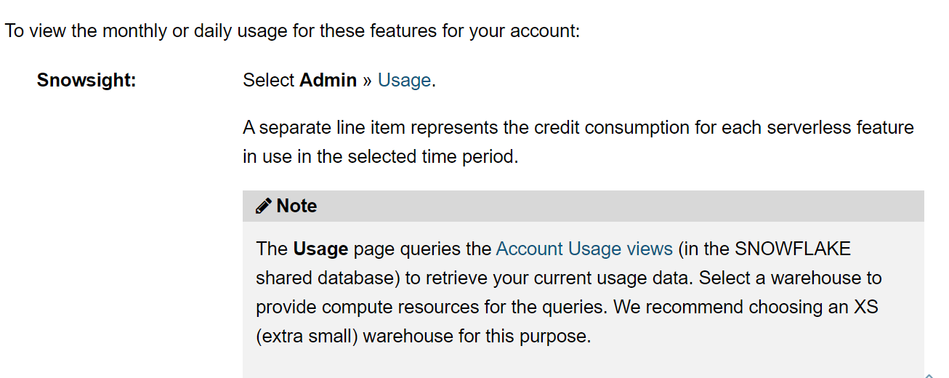

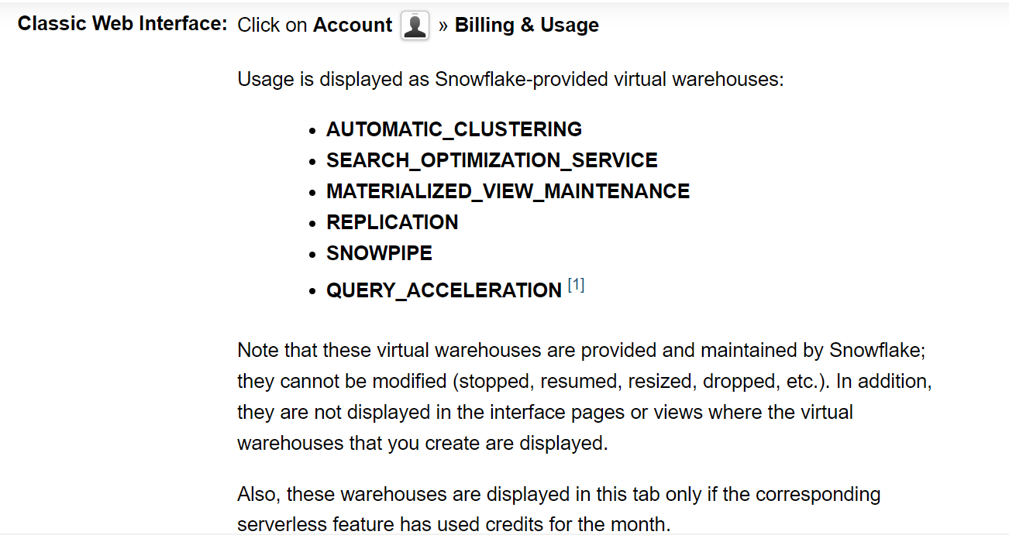

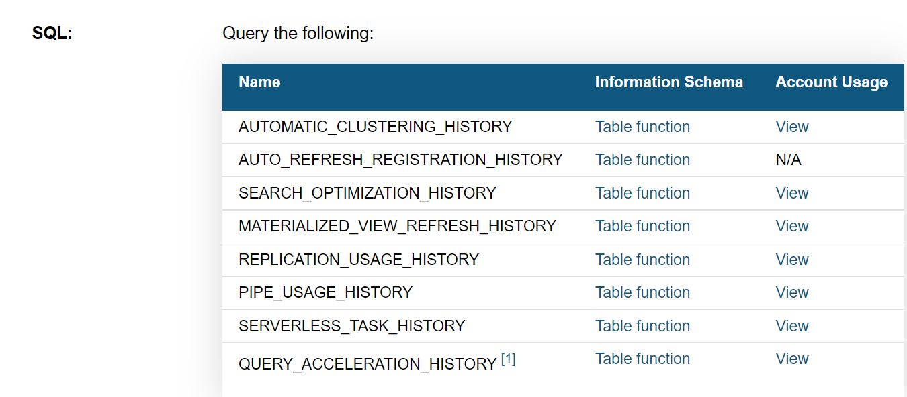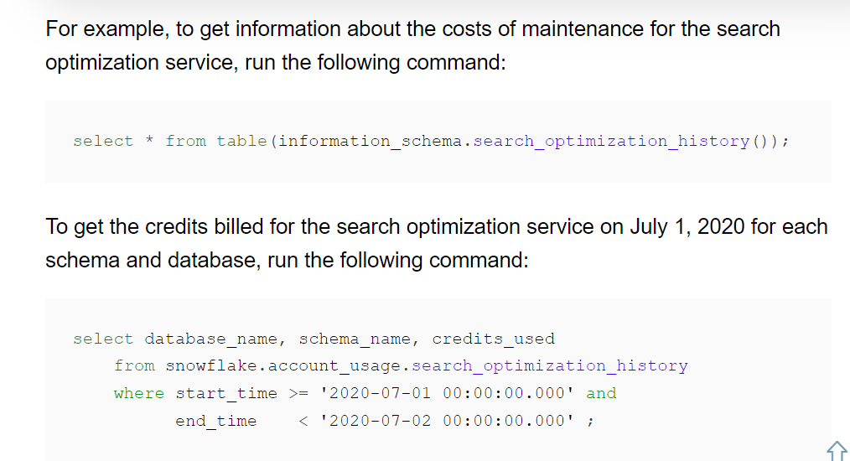

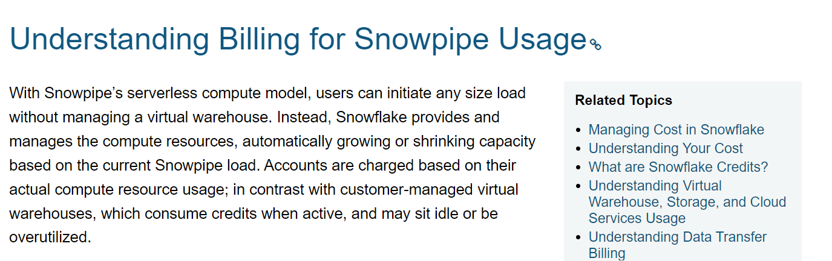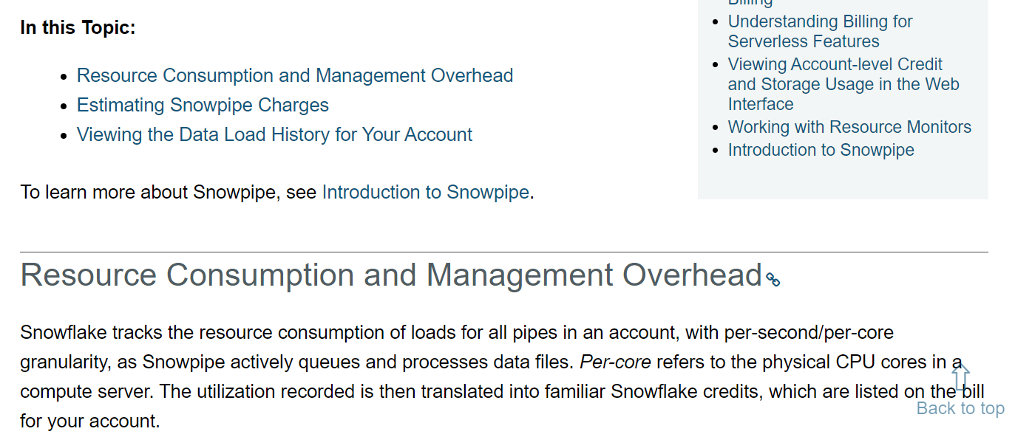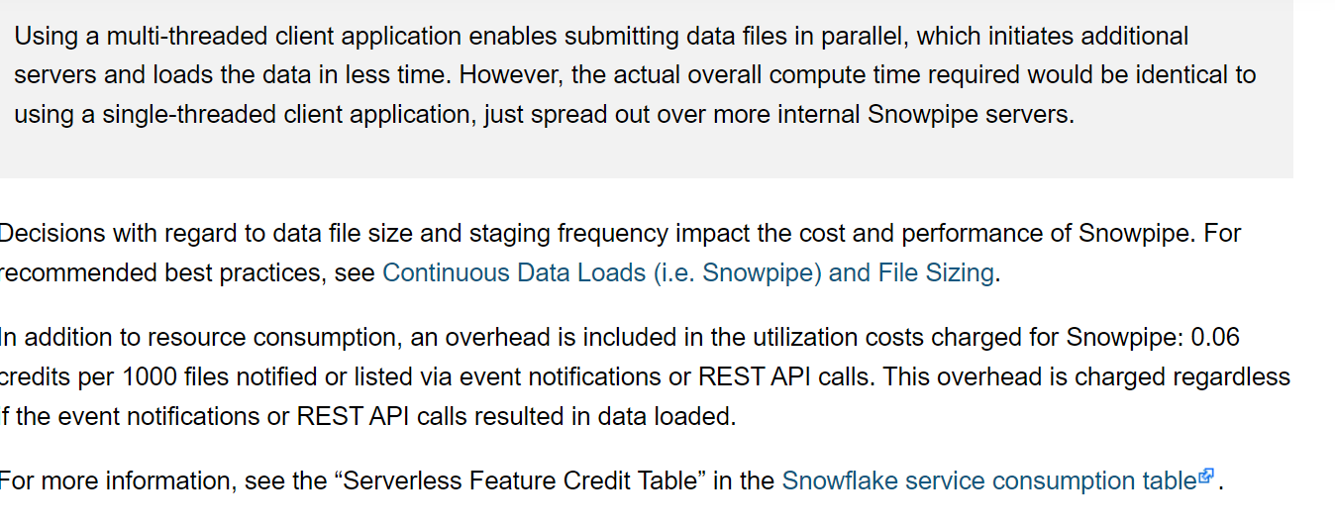

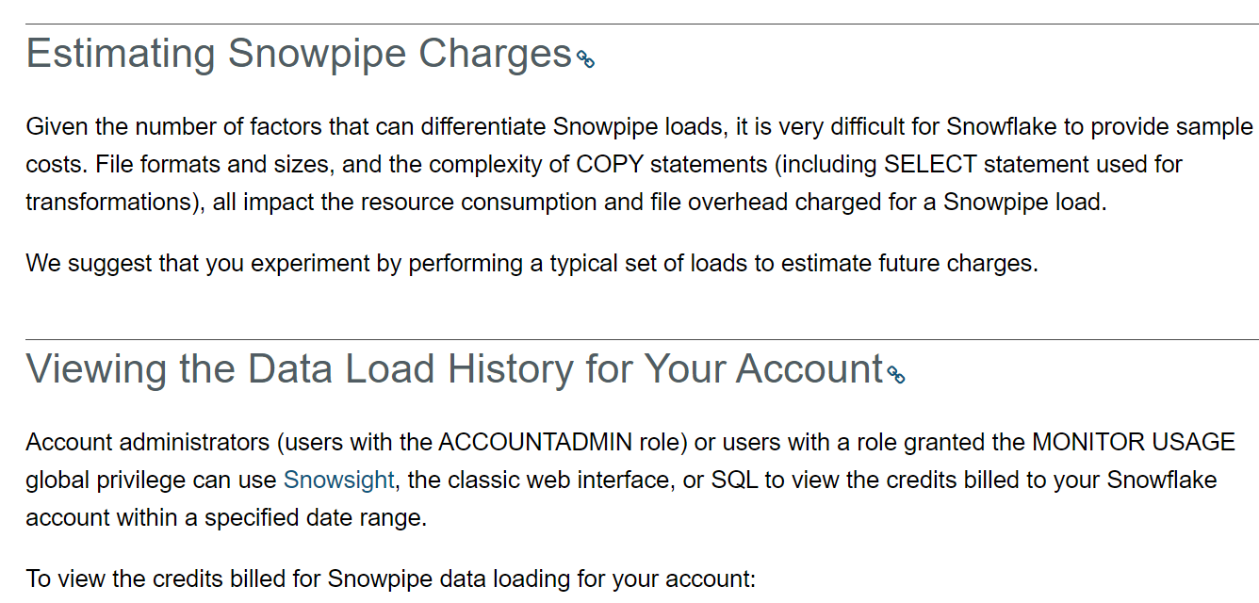

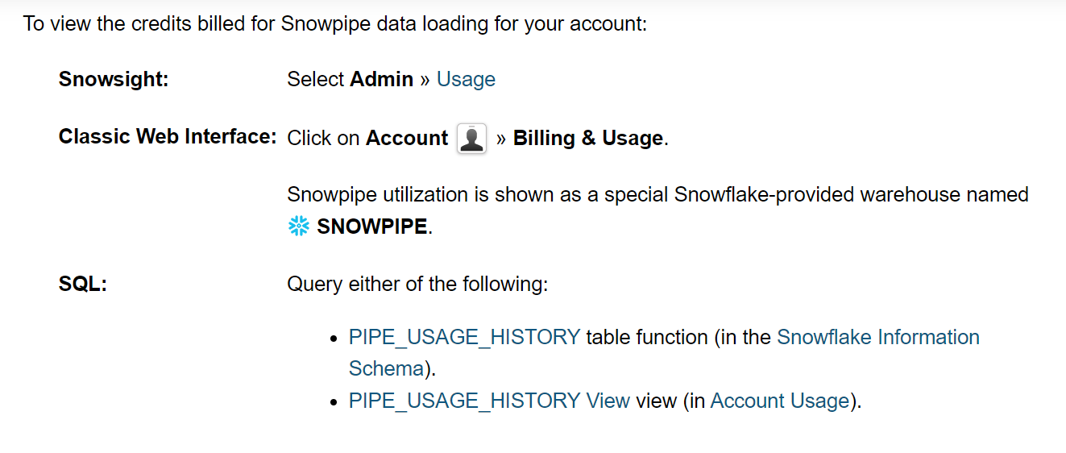

TYPES OF STAGES: (19.6.22)

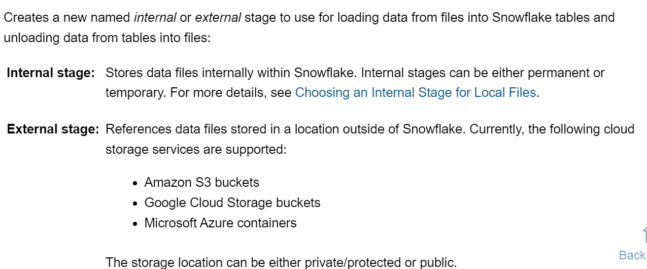

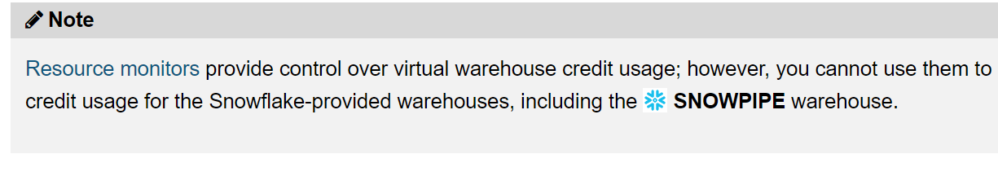

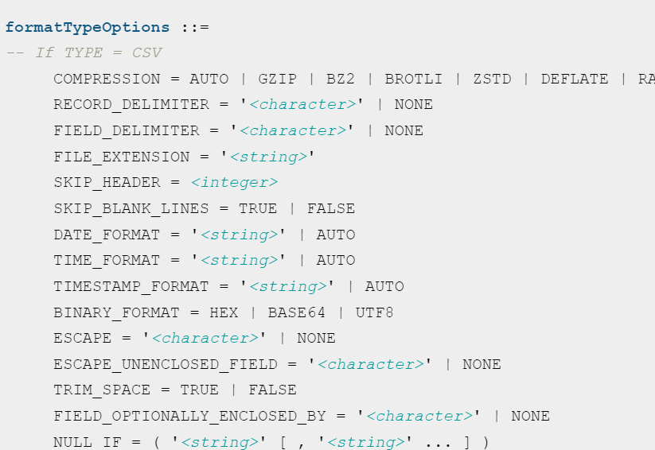

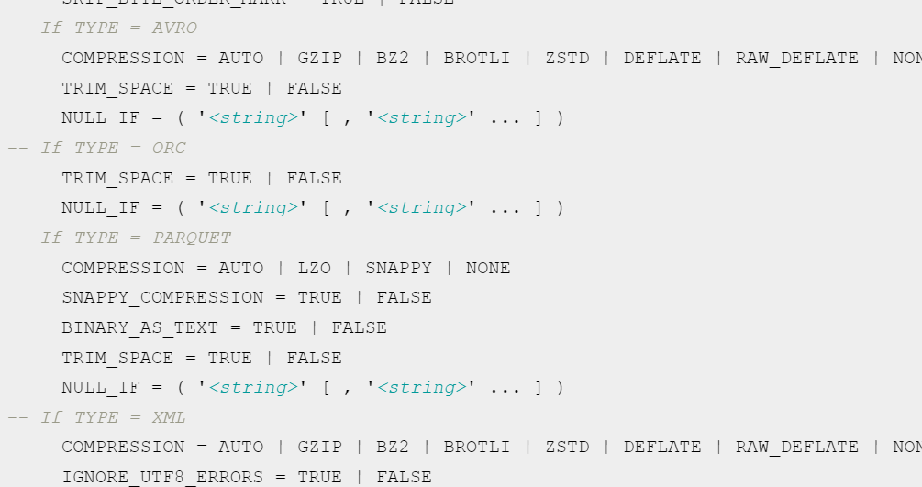

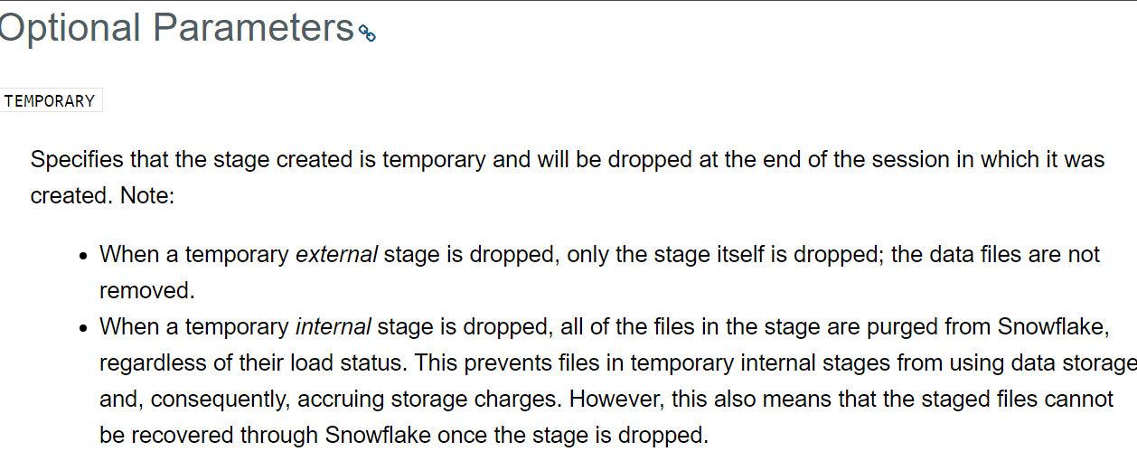

TOPICS to revise:

* 1. **Encryption keys and file format for loading and unloading data (important)**
  2. **Password policy in sSF**
  3. **To use FORCE in loading and unloading**
  4. **Sharing database (clone and resharing)**
  5. **Encryption over network**
  6. **Bulk loading (instages as well as snowpope)**
  7. **Drivers and connectore in web UI**
  8. **Objects that can be shared (table, ET, secure views, secured udf and secure mv’s)**
  9. **Objects that can be cloned(table,schema, database,streams, pipes with external stage,tasks,stages,file formats, sequence)**
  10. **CAST Command**
  11. **Clustering and reclustering**
  12. Materialized view
  13. Kafka
  14. **UDF**
  15. **Shares can have multiple database?**
  16. Micropartitions
  17. **Stroed procedures**
  18. **DDL statements and DML statements in snowflake with warehouse**
  19. **Clustering order by**
  20. **Setting context (by UI as well query)**
  21. **Semi structured data key value pairs**
  22. **Unload file size and load file size**
  23. **Data share (no.of,databases , no.of shares, no.of consumsers)**
  24. **Natural clustering algorithm**
  25. **Put command**
  26. **Get command**
  27. **Snowflake releases (three releases)**
  28. **Which of the following statements are true with respect to the Snowflake release process? 1. Snowflake deploys new feature releases and/or patch releases every week. 2. Snowflake deploys patch releases every week, but new feature releases happen once a month. 3. There’s minimal downtime associated with Snowflake depending upon the content of the release. 4. It is possible for you as a user to request 24-hour early access to the upcoming releases so that you can do additional release testing before the release is rolled out.**
  29. **Snowflake transactions**
  30. **Transient AND TEMPORARY tables**
  31. Put command
  32. Market place
  33. Calcutae for less partitions scanned and for more partitions
  34. Snowpipe (to redo) and re study
  35. Kafta connector (to read)
  36. Named stages and user stage for copy transformations (why)
  37. Can we change the table types after creation?
  38. Read again about cloning (all table types and database objects in cloning
  39. DAC AAND RBAC
  40. Put (overwtite tue in cloud service) how?
  41. Clustering (important)

NOTES: (VERY IMPORTANT)

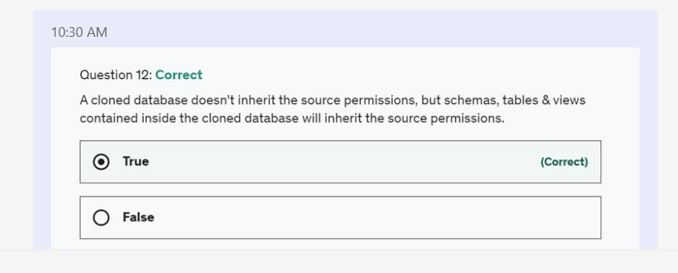

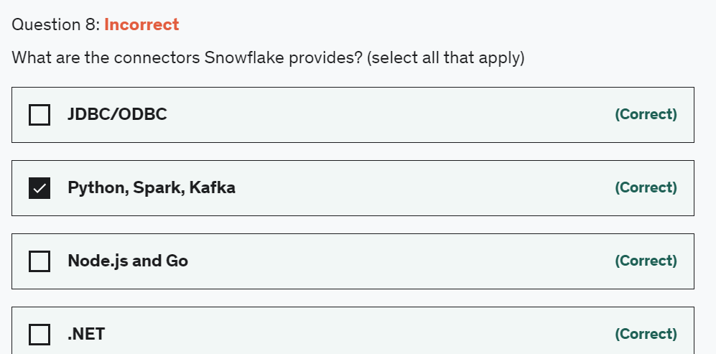answer wrong

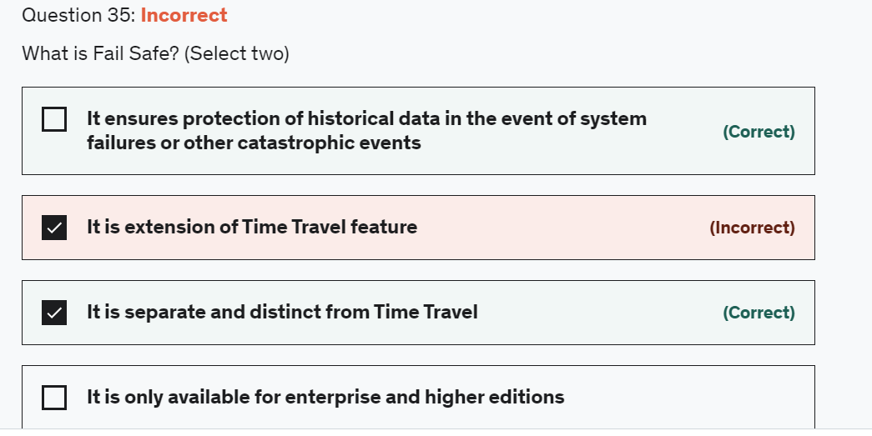

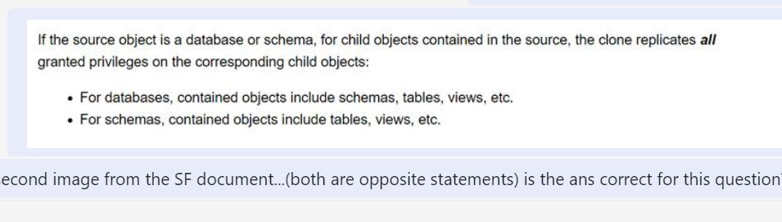

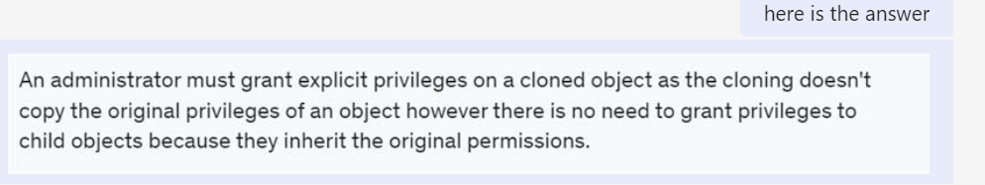

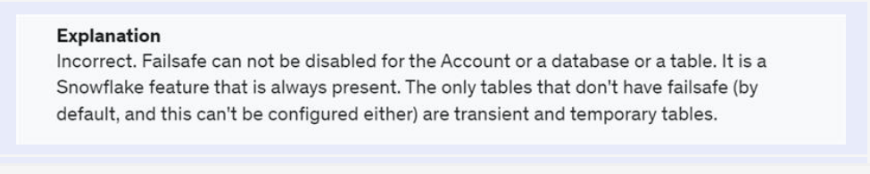

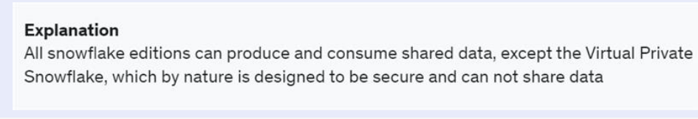

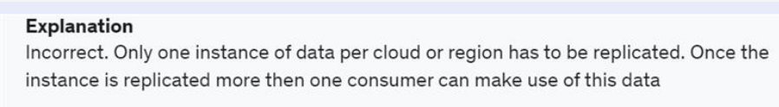

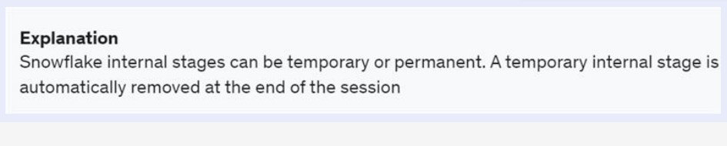

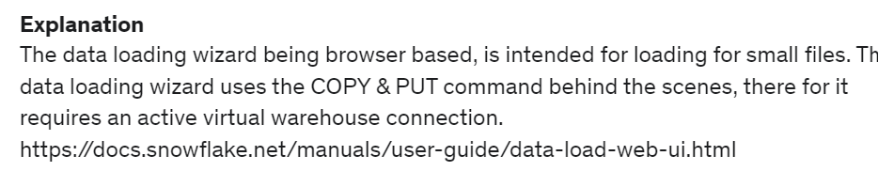

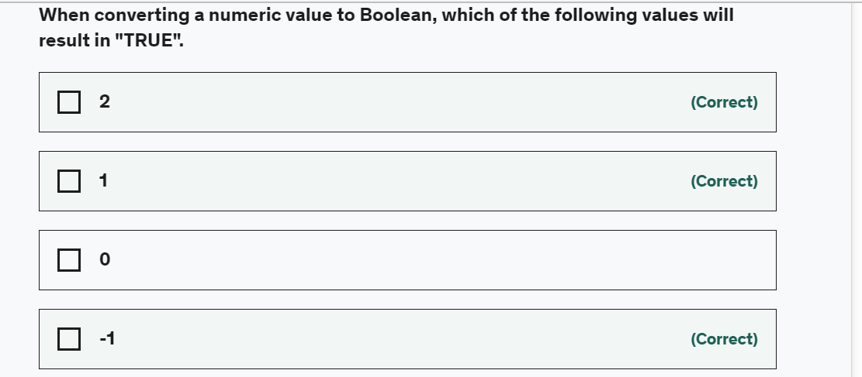

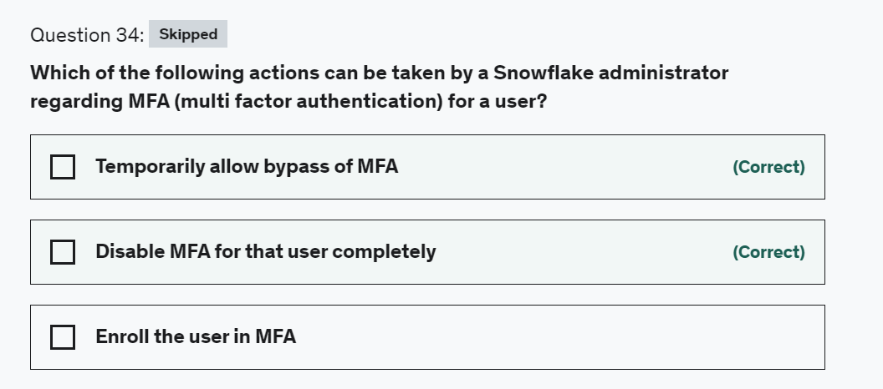

Enrolling should be done by themselves

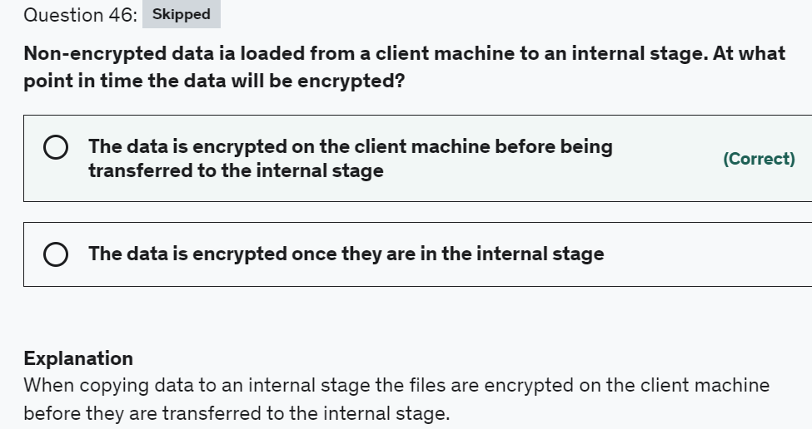

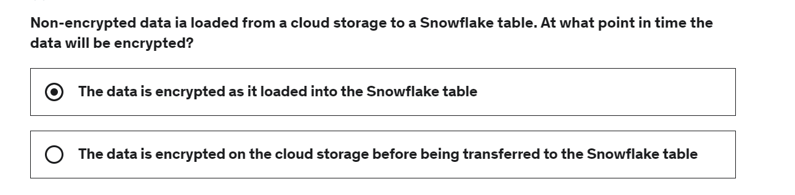

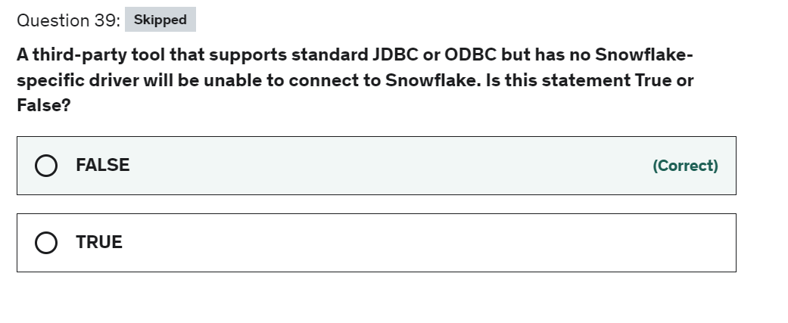

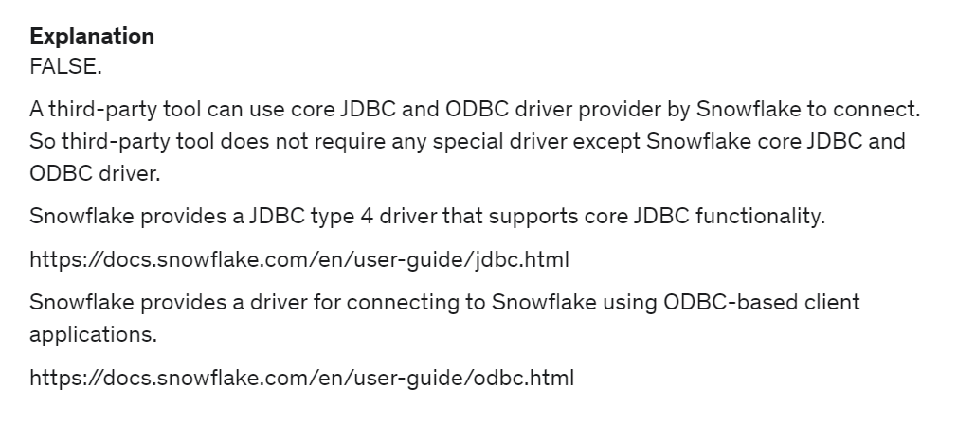

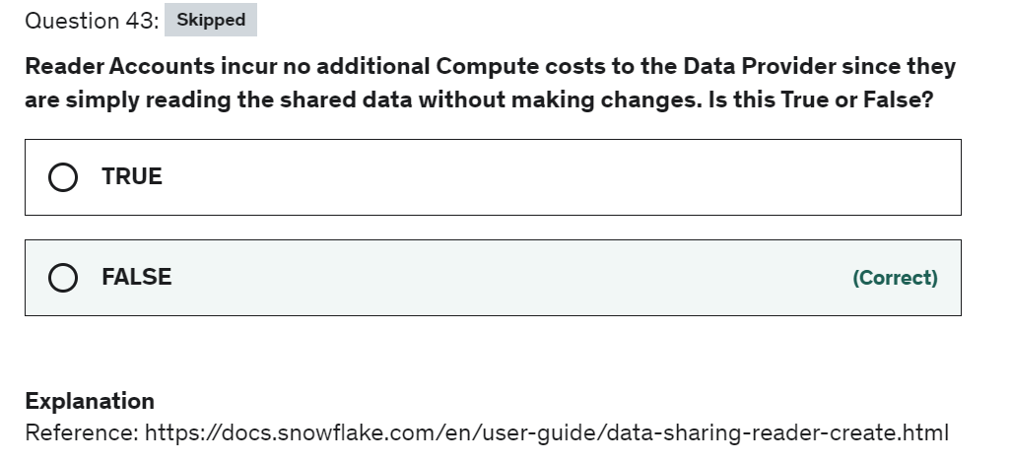

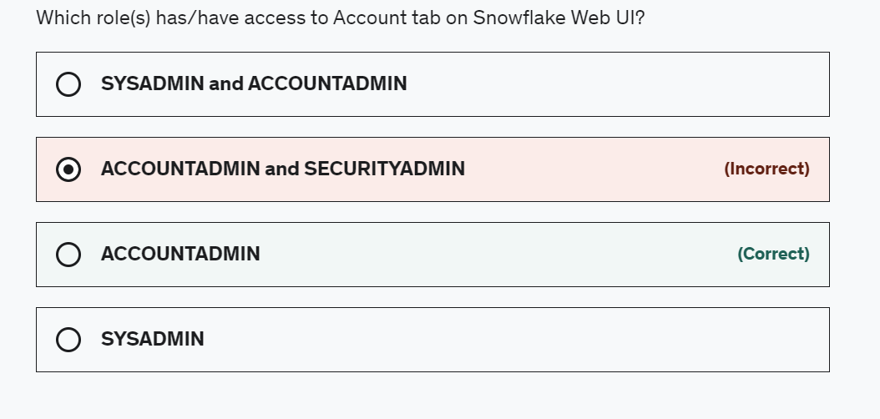

Answer incorrect

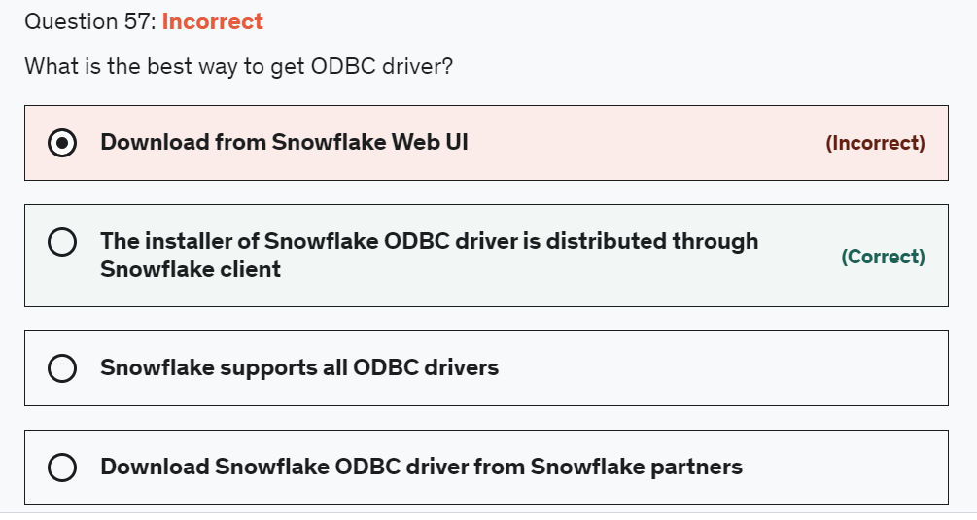



Incorrect answer

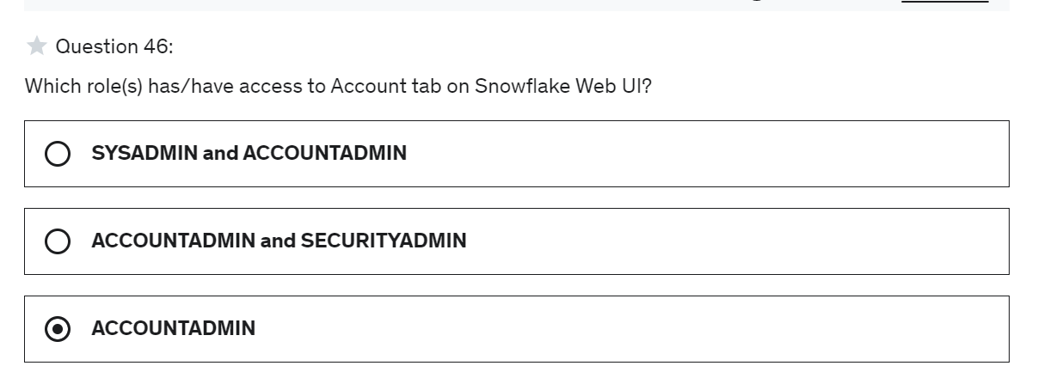incorrect ans

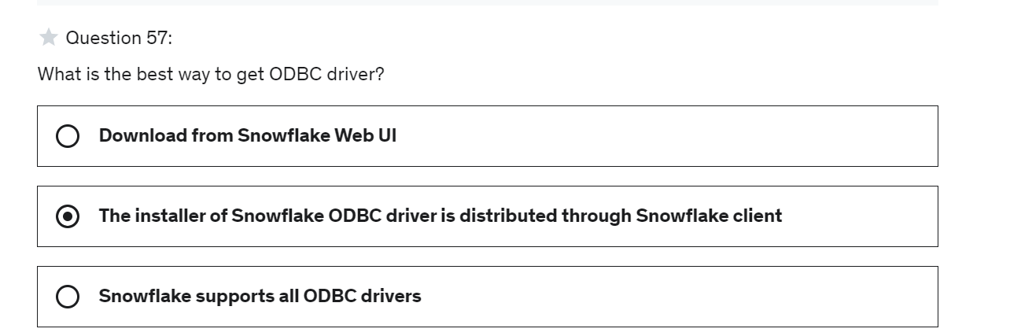

Wrong ans

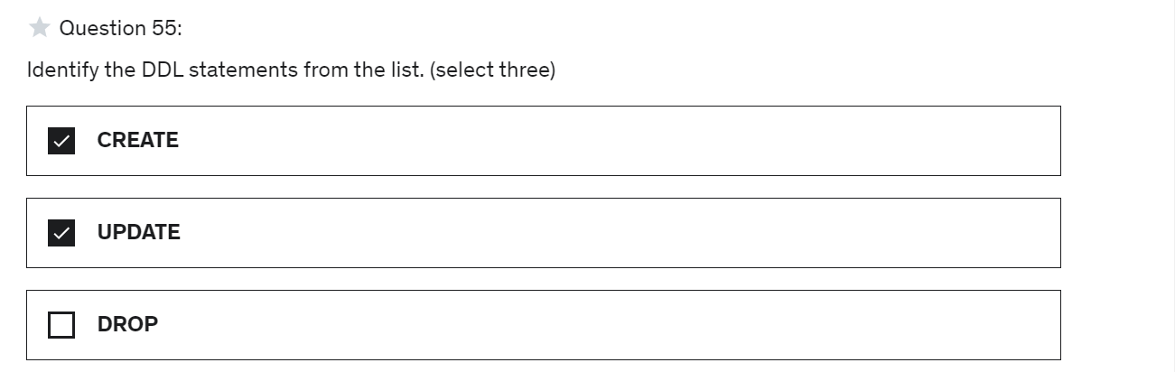

Wrong question

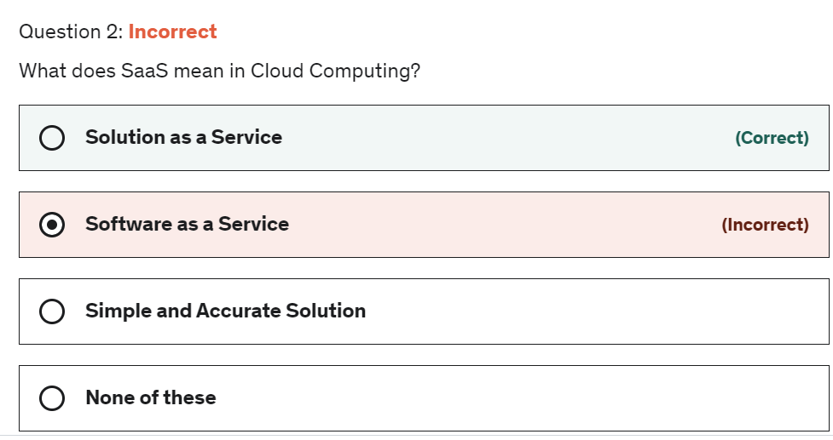

Wrong ans (1)

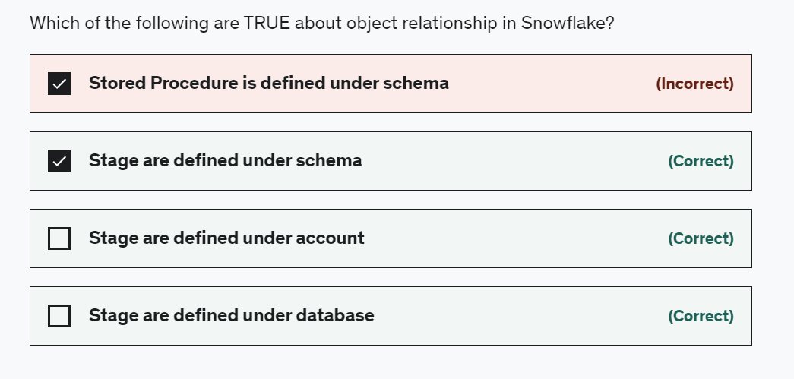

First option seems correct

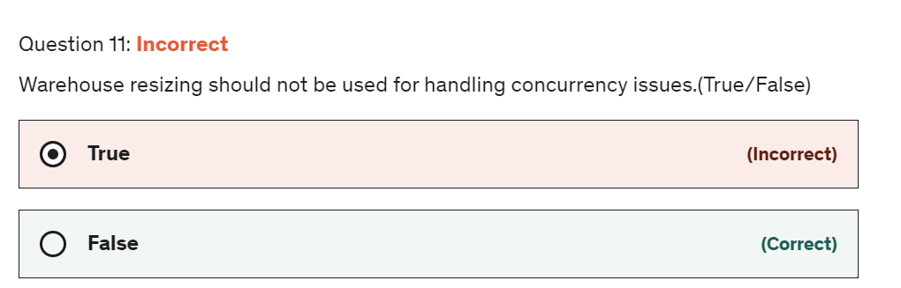

When I click right ans it is showing the other option

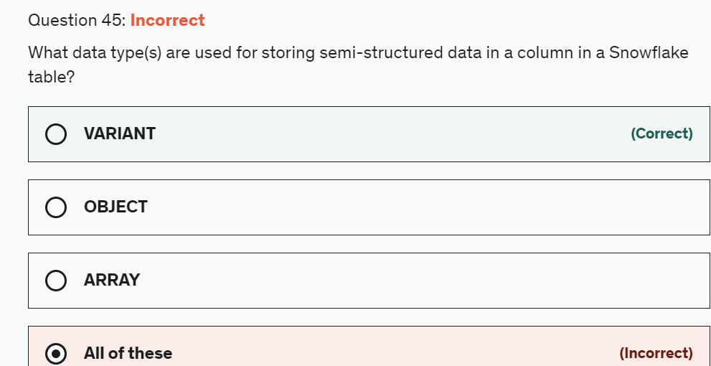

Wrong ans

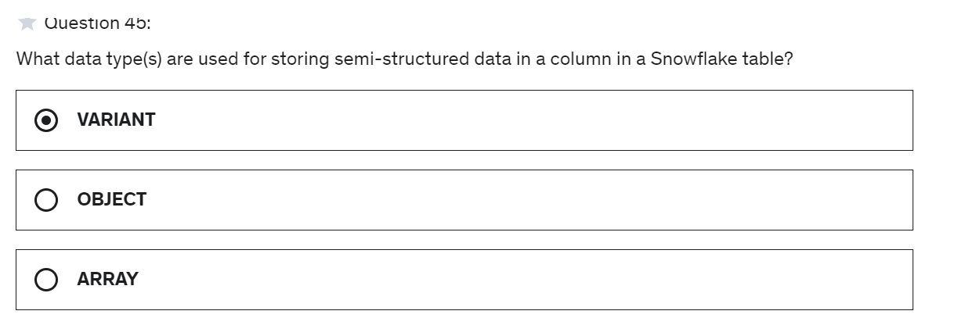

Wrong ans

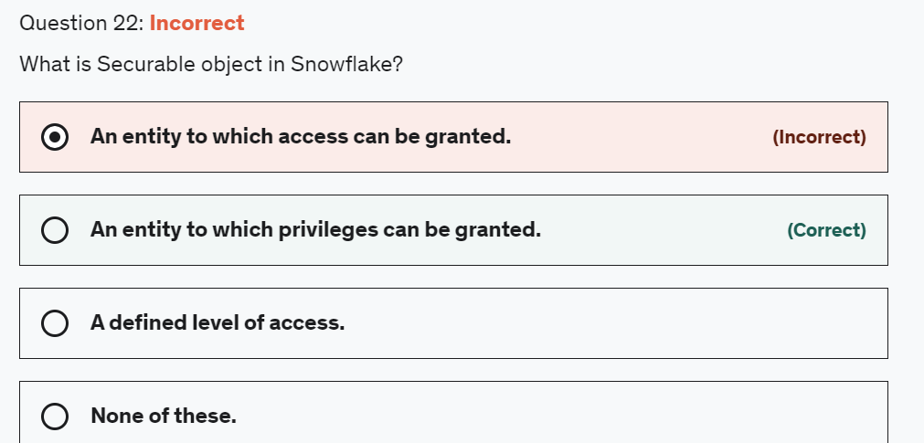

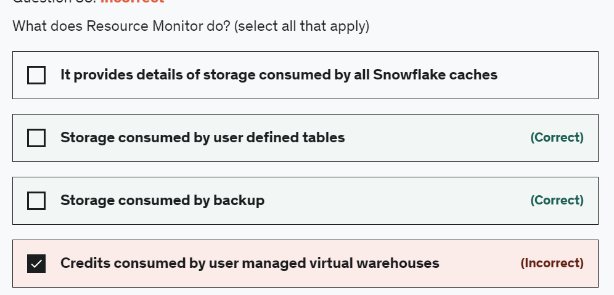both the ans wrong

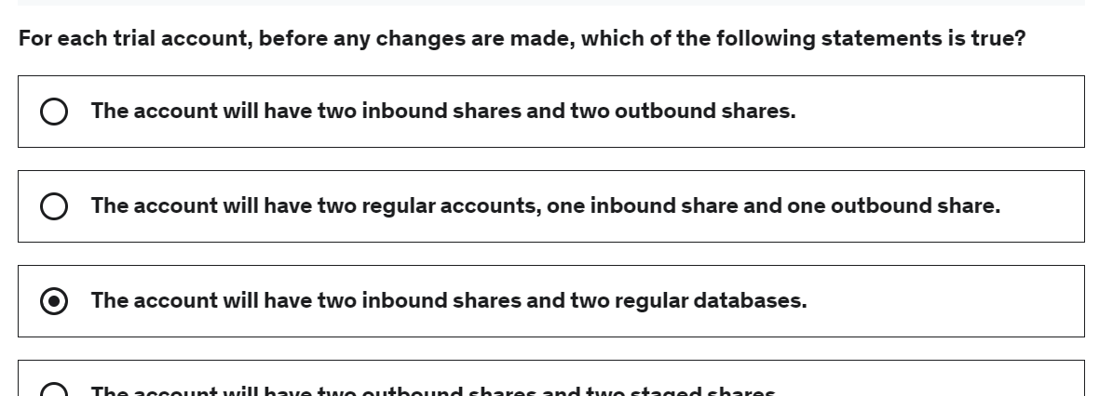

Not able to understand

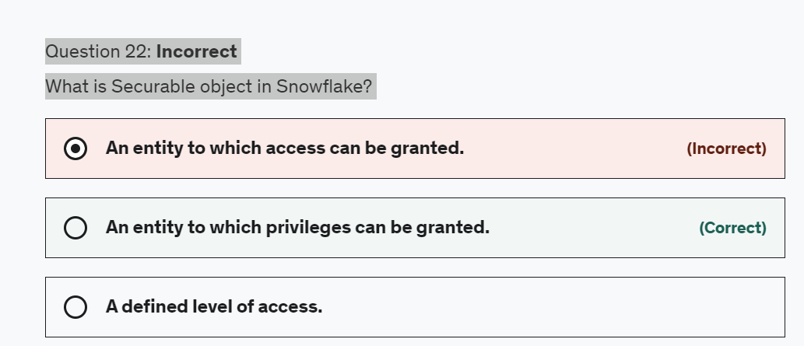

Wrong ans

